**NSSA221 Systems Administration I**

**Lab 04 Report**

# Name: Marveh Mustafa - Rania Kanaan - Suhaila Alfalasi - Saeed Falaknaz - Alia AlYammahi Grade ___/50

**Requirements:**

Use this document to answer questions related to Lab 04. Submit this template to the LR04 drop box by the due date. Late submissions are subject to a 20% penalty. You must use this template and submit the document in Microsoft Word any other format will result in a zero grade for the report.

When submitting your material, please use the following format; LRXX, followed by an underscore, and the first initial of your first name in uppercase, and your entire last name with the first letter in uppercase. Example: LR00_GArcoraci.doc.

Answer ALL questions in your OWN words. Your answer should give some indication that you understand the topic in question and can relate it to your experience in the lab, and not a general textbook answer. DO NOT copy and paste or plagiarize. You may use an outside resource and cite it accordingly to support your answer, but it should **NOT** be your entire answer.

Your answers must be complete sentences and use proper sentence structure. Phrases or one word responses will receive a zero.

1. (10 points) Explain in your own words the following RAID concepts. What are the advantages and disadvantages of using each if there are any?

* Mirroring
* Striping
* Parity
* Fault Tolerance

1. Mirroring: Level 1 RAID employs mirroring, which is a concept used to create a duplicate copy of your data on one or more disks; all data that you wish to duplicate that is available on your disk will be copied to another disk; this ensures data redundancy (Girish, 2023).

Advantages: The mirroring RAID concept is wonderful for reading performance and much easier to construct and use than other RAID concepts. It also provides data redundancy and is a great concept to deploy in the event of a disk failure (Girish, 2023).

Disadvantages: Unfortunately, the mirroring RAID concept restricts your storage space capacity and also has an influence on writing performance because it requires the system to perform better to rewrite the data on multiple drives, and as a result, it affects the writing's speed (Girish, 2023).

1. Striping: The striping principle is used in RAID 0 configurations. Striping is a concept that involves separating and dividing the data into smaller and equal bits on multiple drives, although it does not offer redundancy (Girish, 2023).

Advantages: The stripping approach improves both reading and writing performance by increasing their speed. Furthermore, the striping concert takes advantage of storage capacity in the drives and is a simple concept and technique to apply (Girish, 2023).

Disadvantages: The striping approach does not manage disk failures or provide redundancy; if a single drive fails and is lost, then the data is lost as well, and it is difficult to recover the lost data (Girish, 2023).

1. Parity: The parity concept is employed on many RAIDs, including RAID 4, RAID 5, and RAID 6. It is a mechanism that calculates the data contained in different drives and then distributes and stores the result, also known as the parity information, in different drives (Simic, 2023).

Advantages: Unlike other RAID concepts, parity provides excellent data redundancy in the event of disk failure; this concept is employed for fault tolerance (Simic, 2023).

Disadvantages: The parity concept has an influence on the system's writing speed, slowing its performance because it requires calculating and updating the parity information (Simic, 2023).

1. Fault tolerance: configurations that offer fault tolerance assist in guarding it against data loss by allowing the system to continue operating in the event of a disk failure. It is crucial to note that not all RAID levels offer fault tolerance (Daniel, 2023).

Advantages: fault tolerance is important for lowering the risk of data loss on the disk drive and ensuring that the system continues to work even if the drive fails (Daniel, 2023).

Disadvantages: Fault tolerance may have an influence on RAID-level performance, such as slowing the system and reducing writing performance. Furthermore, fault tolerance is more difficult to implement since it could require additional hardware (Daniel, 2023).

1. (10 points) Explain the limitation of using an MBR partition table. And the benefits of using a GPT partition table in modern Linux systems.

On storage devices, the MBR AND GPT partition tables are utilized to manage partitions. The MBR partition table has been used for a long time, but unfortunately, it has several drawbacks. For example, the MBR has a restricted partition size, a 32-bit addressing method, and no data redundancy. The GPT table, on the other hand, has a much larger partition size, and is utilized for high-capacity storage, and, unlike the MBR table, offers data redundancy for usage in the event of a disk drive failure (Kanade, 2023).

1. (10 points) Explain the purpose of primary, extended, and logical partitions.

The primary partition is used to store operating systems and can have up to four primary partitions on the disk drive. However, one of its disadvantages is that you can only have up to four primary partitions. You will need to construct an extended partition if you wish to have multiple partitions. The logical partition is used to store data, and it is located within an extended partition, which has more than four partitions. If you want to create even more logical partitions, you can do so by creating them in the extended partitions. The extended partition is used to store logical partitions, allowing you to store more data on your drive. You can only have one extended partition on your disk drive (Dervish, 2023).

1. (10 points) What are the columns in the */etc/fstab* file and what is their primary function?

The “/etc/fstab” filesystem table in Linux includes information about file systems as well as mounting and unmounting information, making it easier for us users to grasp. The “*fstab”* file system table has the following columns (Carrigan, 2020):

1. Device: the name or UUID of the mounted device or partition is provided by the device column.
2. Mount Point: the mount point indicates where the device will be mounted.
3. File System Type: the file system type indicates the type of filesystem that can be utilized.
4. Options: The options column displays the mount choices and how to mount them.
5. Backup Operation: backup operation (dump), which indicates when a filesystem backup should be generated.
6. File System Checker: the file system check order column specifies which filesystems should be examined in order.
7. (5 points) As a systems administrator explain how Logical Volume Management is more flexible and efficient than using partitions

Compared with traditional on-disk partitions, Logical Volume Management (LVM) provides a higher degree of flexibility and efficiency for the systems administrator. LVM adds a layer of abstraction between physical partitions and the filesystems they hold, serving as the Linux Kernel's storage virtualization. Logical Volumes (LV) are formed in LVM to hold filesystems once Physical Volumes (PV) are joined to create Volume Groups (VG). Flexible capacity, which enables filesystems to span multiple disks; resizable storage pools that can be increased or decreased without reformatting or repartitioning; online data relocation for devices that are in use; user-defined classes device naming; disk striping for increased efficiency; mirroring volumes for data redundancy; and volume snapshots for reliable backups or testing the effects of changes without affecting real data are some of LVM's main benefits. The dynamic and effective approach to storage management offered by LVM's capacity to manage physical volumes, volume groups, and logical volumes on the fly allows for the smooth growth, reallocation, and maintenance of storage resources (Gupta, 2019).

1. (5 points) Windows Systems use Dynamic and Basic disk storage types. What similarities or differences are there between these types and Linux disk storage types?

Basic and Dynamic disk storage types in Windows have different properties. Basic disks use standard partition tables and are capable of holding three or four MBR or GPT partitions. They allow multi-boot setups, may be quickly changed to dynamic disks without losing data, and can be used with older operating systems. Partitions are used by basic disks to handle data; they may be created, deleted, and formatted. Conversely, dynamic disks enable unrestricted partitioning flexibility by dividing the hard drive into dynamic volumes. They don't allow multi-boot, but they do have basic, spanned, striped, mirrored, and RAID-5 volumes. Boot loaders are not used by dynamic disks, which are limited to Windows 2000 and later, and need cautious conversion to basic disks. Actively managing data through volumes, dynamic disks may be created from scratch or converted from basic drives. Tasks include maintaining RAID setups, expanding volumes, reactivating lost disks, and creating and deleting volumes (Difference between basic disk and dynamic disk, 2020).



Make sure to include all screenshots for the report. For each missing screenshot, you will receive a 5% penalty for the grade. If your screenshots do not have the required information, are illegible, blurry, or unreadable, you will not receive credit. Any attempt to alter the information in the screenshots is dishonesty, and you may fail the course.

**All screenshots must be labeled using the following titles.**

**Figure 1** – Drives Added Verification

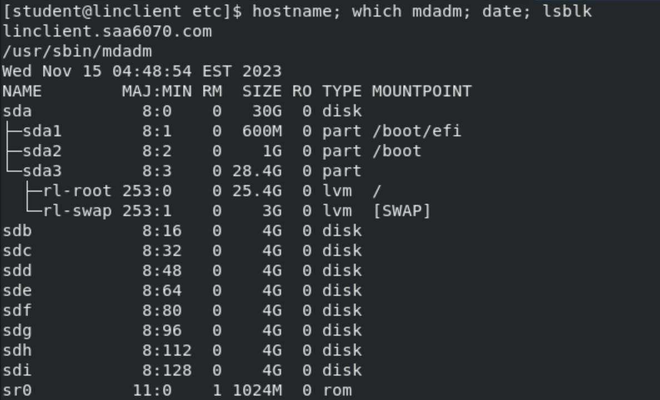

**Figure 2** – Drive Mounted Verification

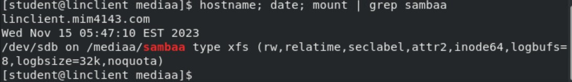

**Figure 3** – RAID 1 Mount Verification

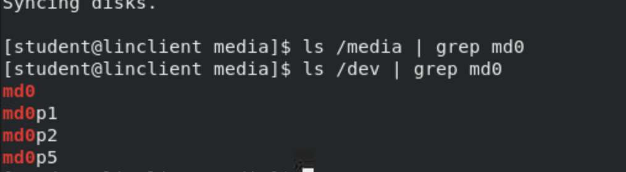

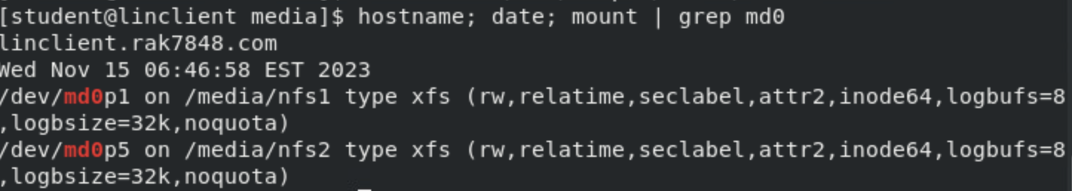

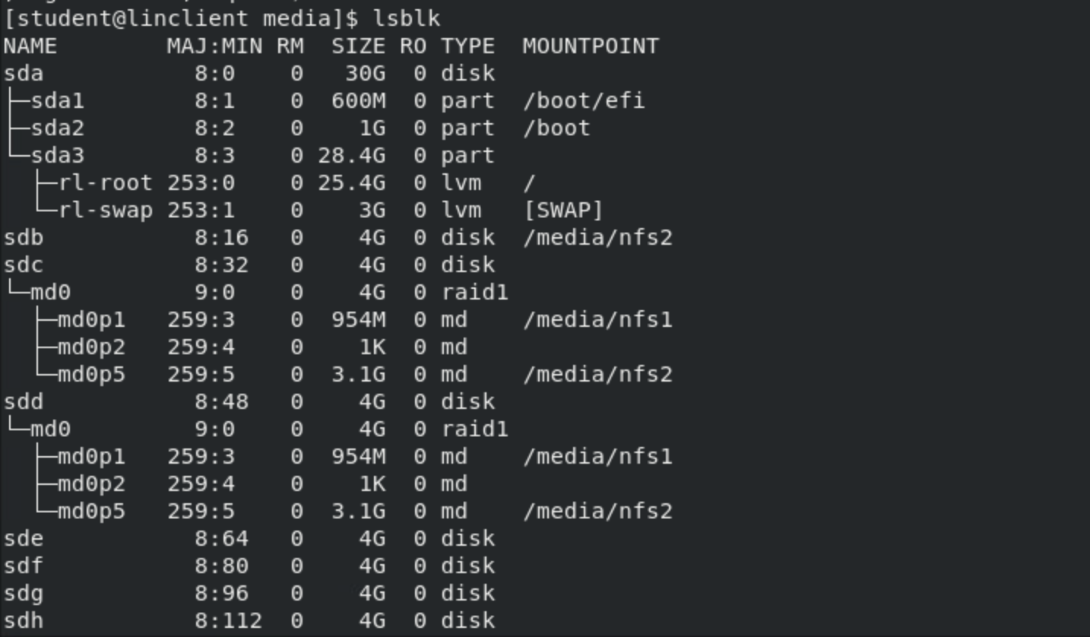

**Figure 4** – RAID 5 Mount Verification

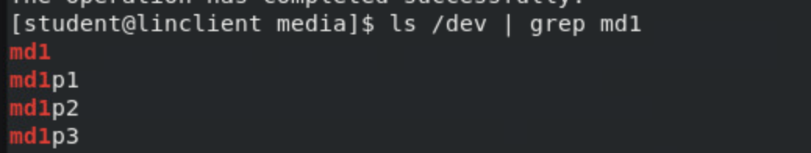

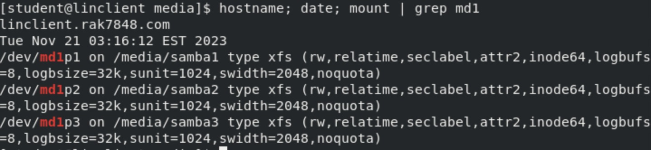

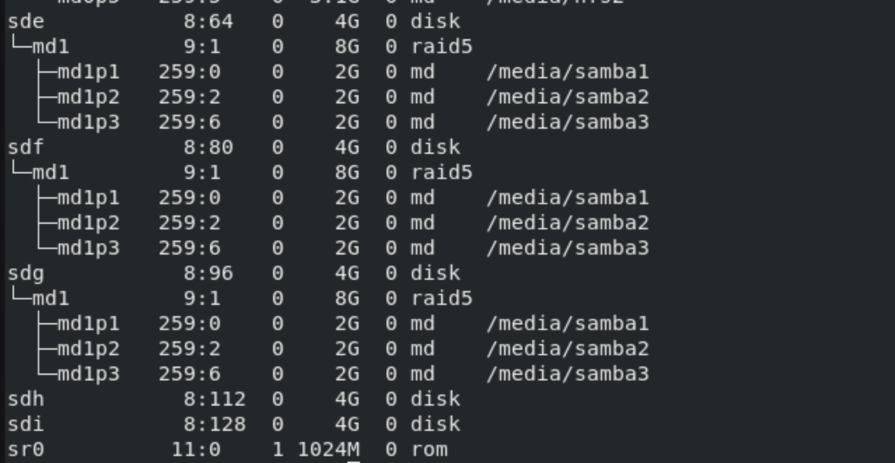

**Figure 5** – Persistent Mount Verification

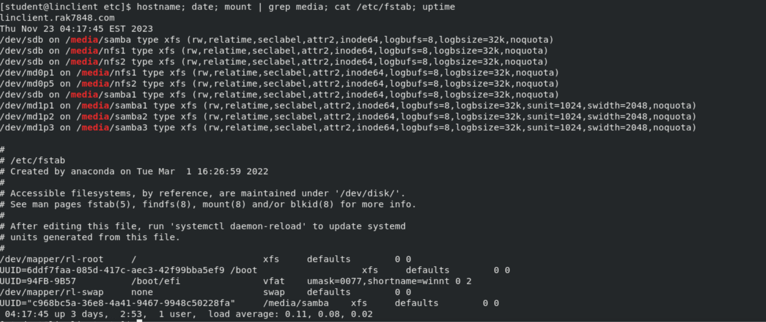

**Figure 6** – RAID Redundancy

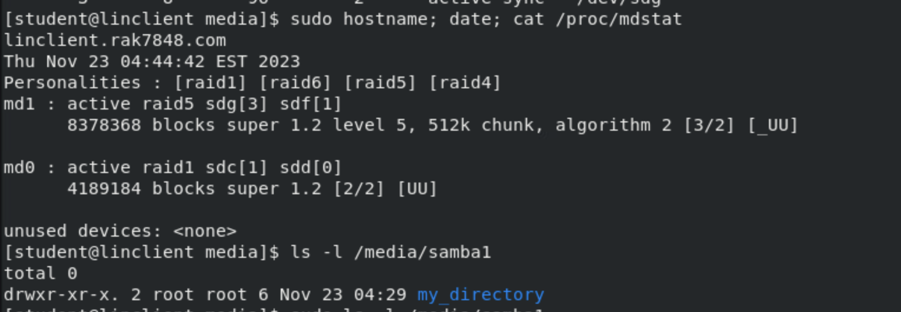

**Figure 7** – Rebuilt RAID Verification

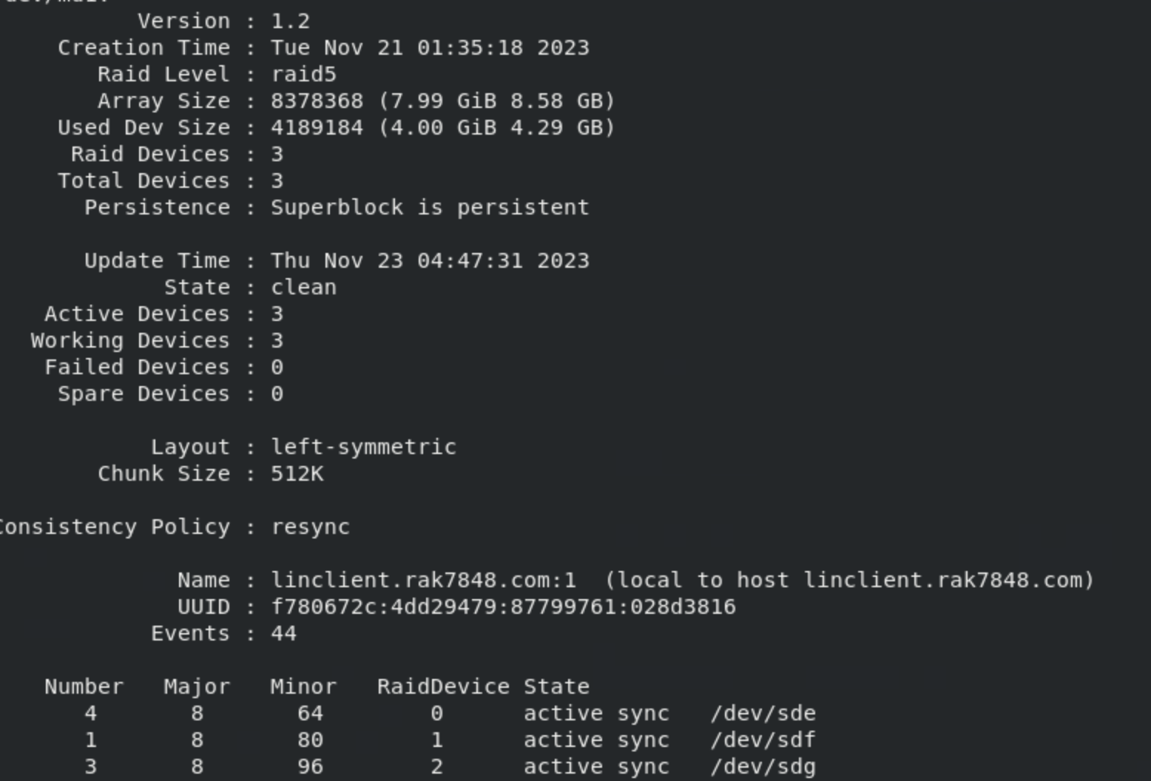

**Figure 8** – LVM Mount Verification

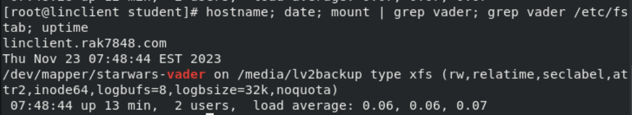

**Figure 9** – LVM Resize Verification

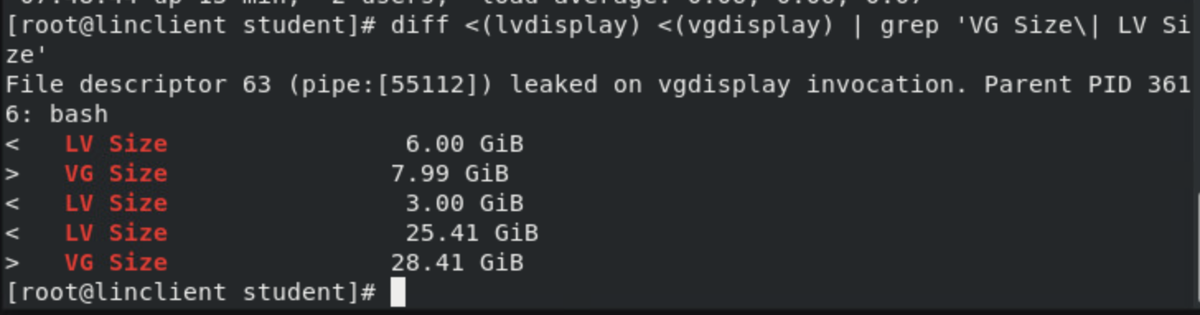

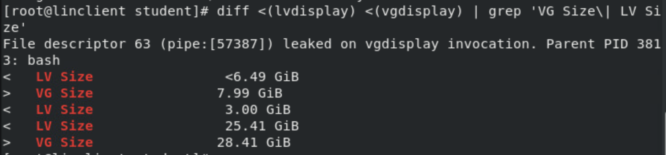

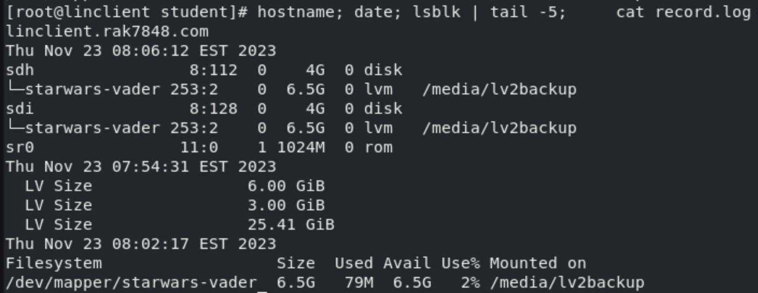

**References:**

Girish. (2023, February 14). Advantages and Disadvantages of Raid Levels - Stellar Data Recovery. Stellar Data Recovery Blog - Tips and Solutions. <https://www.stellarinfo.co.in/blog/advantages-and-disadvantages-popular-raid-systems/>

Simic, S. (2023, July 10). Raid Levels and Types Explained: Advantages and Disadvantages. Knowledge Base by phoenixNAP. <https://phoenixnap.com/kb/raid-levels-and-types#ftoc-heading-15>

Daniel, B. (2023, March 7). RAID Levels 0, 1, 5, 6 and 10 & RAID Types (Software vs. Hardware). [https://www.trentonsystems.com/blog/raid-levels-0-1-5-6-10-raid-types#:~:text=Configurations%20that%20 offer%20data%20 loss,Hardware%20RAID](https://www.trentonsystems.com/blog/raid-levels-0-1-5-6-10-raid-types#:~:text=Configurations%20that%20offer%20data%20loss,Hardware%20RAID).

Kanade, V. (2023, July 11). Master Boot Record (MBR) vs. GUID Partition Table (GPT): What’s Best for You? Spiceworks. Retrieved November 20, 2023, from [https://www.spiceworks.com/tech/hardware/articles/mbr-vs-gpt-the-best-choice-for-your-computer/#:~:text=Assess%20 partitioning%20needs%3A%20If%20you,primary%20and%20one%20 extended%20partition](https://www.spiceworks.com/tech/hardware/articles/mbr-vs-gpt-the-best-choice-for-your-computer/#:~:text=Assess%20partitioning%20needs%3A%20If%20you,primary%20and%20one%20extended%20partition).

Dervish. (2023, May 12). Primary Partition, Logical Partition and Extended Partition. <https://www.diskpart.com/resource/disk-partition-basic-understanding.html>

Carrigan, T. (2020, June 19). An introduction to the Linux /etc/fstab file. Enable Sysadmin. <https://www.redhat.com/sysadmin/etc-fstab>

Difference between Basic Disk and Dynamic Disk. (2022, August 4). GeeksforGeeks. <https://www.geeksforgeeks.org/difference-between-basic-disk-and-dynamic-disk/>

Gupta, V. (2021, December 13). LVM in Linux - Vivek Gupta - Medium. Medium. <https://medium.com/@cloud2help/lvm-in-linux-dc9b34ecbf29>